Assignment Details:
Practical 1 to 5 (Dhruval Gamit)

Assignment - 1

Practical - 1 : Install Node.js (LTS) and verify the installation by running node -v and npm -v in your terminal. Take a screenshot of the output.

Step 1: Download Node.js (LTS)
- Open your web browser.
- Go to the official Node.js website:
  - https://nodejs.org
- You'll see two versions:
  - LTS (Long-Term Support)
  - Current
- Click Download Node.js (LTS).

Step 2: Install Node.js
- Open the downloaded .msi installer.
- Click Next.
- Accept the License Agreement.
- Click Next.
- Leave the default installation location unchanged.
- Click Next.
- Keep all default features selected.
- Click Next.
- Leave the option for Automatically install the necessary tools unchecked unless instructed by your course.
- Click Install.
- If Windows asks for permission, click Yes.
- Wait until installation finishes.
- Click Finish.

Step 3: Open Terminal and Verify Node.js Installation
Type
node -v
Press Enter.
Output
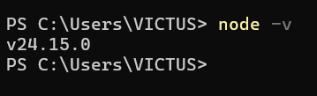

Step 4: Verify npm Installation
Type
npm -v
Press Enter.
Output
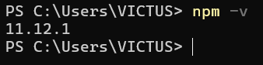

If Commands Don't Work
If you get
'node' is not recognized...

Restart your computer first.
If it still doesn't work:
- Uninstall Node.js.
- Install it again.
- Ensure Add to PATH is enabled (it usually is by default).
- Open a new Command Prompt and try again.

Practical - 2 : Install Angular CLI globally using npm and verify it with ng version. Note down the Angular CLI version installed on your machine.

Prerequisites
Before starting, make sure:
- Node.js is installed.
- npm is working.
Verify by running:
node -v
npm -v
If both commands display version numbers, continue.

Step 1: Open Command Prompt
Press Windows + R, type:
cmd

and press Enter.

Step 2: Install Angular CLI Globally
Type the following command:
npm install -g @angular/cli

Press Enter.

What this command does
- npm → Node Package Manager
- install → Installs a package
- -g → Installs it globally so you can use ng from any folder
- @angular/cli → The Angular Command Line Interface package

Step 3: Wait for Installation
The installation may take 2–5 minutes, depending on your internet speed.
You may see output similar to:
added 250 packages in 40s

or
changed 250 packages

This indicates the installation completed successfully.

Step 4: Verify Angular CLI Installation
Run:
ng version
or
ng v

output:

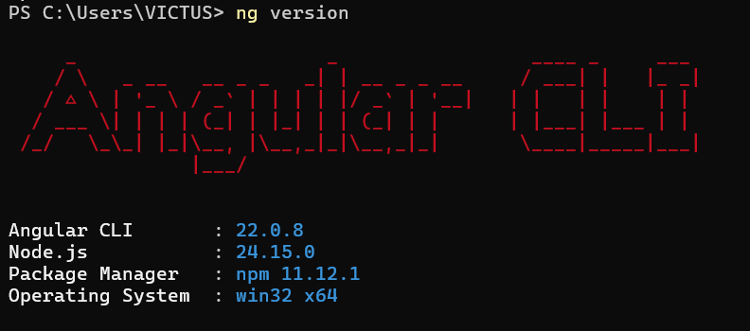

Both commands display the installed Angular CLI version.

If You Get an Error

Error:
'ng' is not recognized as an internal or external command

Try these steps:
- Close the Command Prompt.
- Open a new Command Prompt and run: ng version
- If it still doesn't work, restart your computer.
- If the issue persists, check whether Angular CLI is installed:
npm list -g @angular/cli
- If it's not installed, run the installation command again:
npm install -g @angular/cli

Practical - 3 : Create a new Angular project called my-first-app, run it using ng serve – open, and confirm it loads at http://localhost:4200.

Step 1: Open Command Prompt
Press Windows + R, type:
cmd

Press Enter.

Step 2: Go to the Folder Where You Want to Create the Project
For example, if you want to create it in the Documents folder:
cd %USERPROFILE%\Documents

Or create it on the D: drive:
D:
cd Projects

Choose any location where you want to save the project.

Step 3: Create a New Angular Project
Run:
ng new my-first-app

Press Enter.

Step 4: Answer the Setup Questions
Depending on your Angular CLI version, you may be asked a few questions.

Example Questions

1. Would you like to create a zoneless application?
Select:
No

(or press Enter if No is the default)

2. Which stylesheet format would you like to use?
Use the Arrow Keys to select:
CSS

Then press Enter.
If your CLI asks slightly different questions, the default options are usually fine unless your instructor specified otherwise.

Step 5: Wait for the Project to Be Created
Angular will:
- Create the project folder.
- Install required packages.
- Display a success message.
You should see something similar to:
✔ Packages installed successfully.
✔ Project 'my-first-app' created successfully.

This may take a few minutes.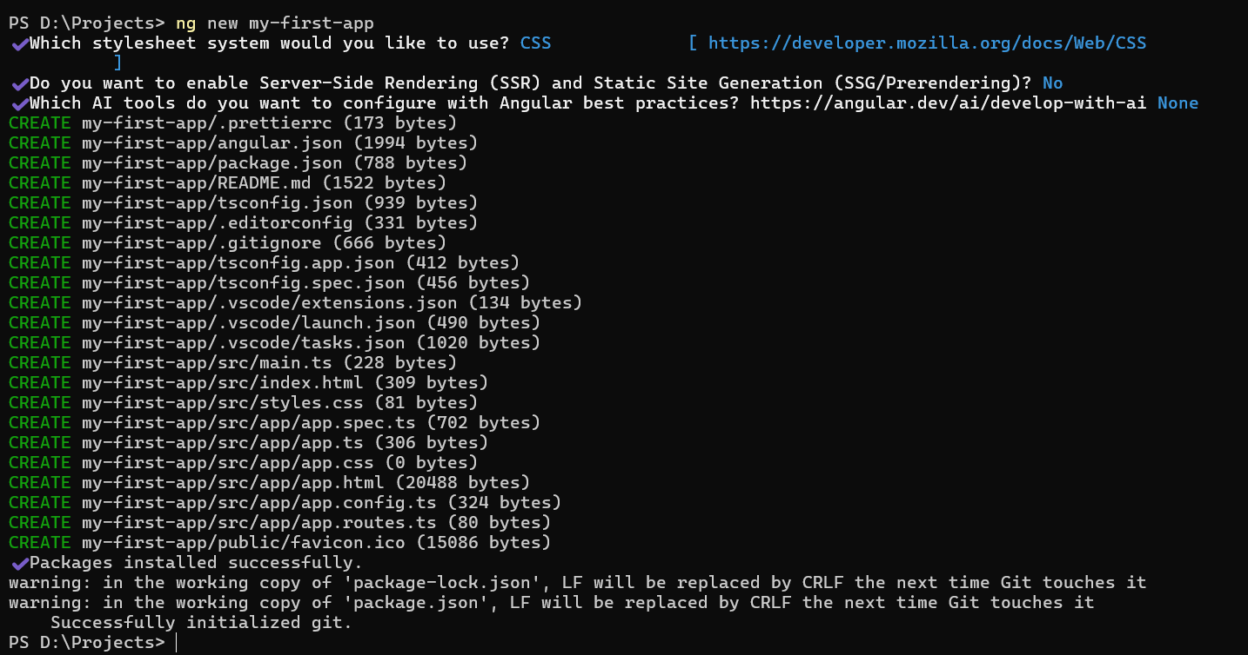

Step 6: Move into the Project Folder
Run:
cd my-first-app

Step 7: Start the Development Server
Run:
ng serve --open

or the shorter form:
ng serve -o
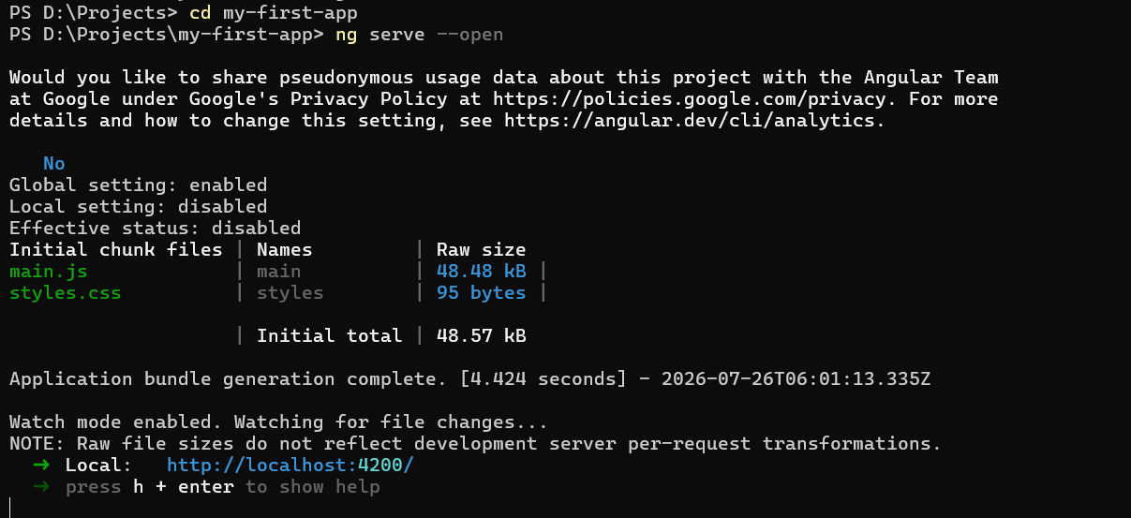

Step 8: Wait for Compilation
You should see output similar to:
✔ Compiled successfully.

and
Local: http://localhost:4200/

Keep this Command Prompt window open while the app is running.

Step 9: Browser Opens Automatically
Your browser should open to:
http://localhost:4200
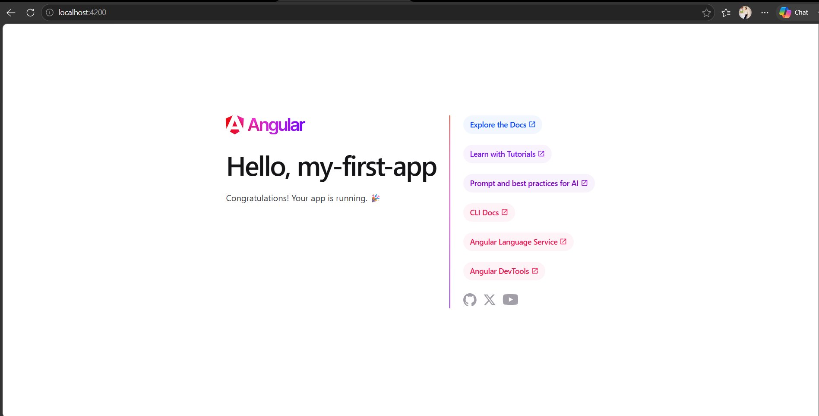
You should see the default Angular welcome page (the exact appearance depends on the Angular version).

If the Browser Doesn't Open Automatically
Open your browser manually and visit:
http://localhost:4200

If Port 4200 Is Already in Use
You may see:
Port 4200 is already in use.

Press:
Y
Angular will use another port (for example, http://localhost:4201).

Assignment - 2
Practical - 1 : To create a TypeScript file named datatypes.ts and demonstrate the use of different TypeScript data types such as string, number, boolean, array, tuple, any, and unknown, and display their values using console.log().

Software Requirements
- Operating System: Windows 10/11
- Node.js (LTS)
- Angular CLI
- Visual Studio Code
- TypeScript Compiler (tsc)

Procedure
- Open the existing Angular project (my-first-app) in Visual Studio Code.
- Create a new file named datatypes.ts inside the src folder.
- Write TypeScript code demonstrating the following data types:
  - String
  - Number
  - Boolean
  - Array
  - Tuple
  - Any
  - Unknown
- Save the file.
- Open the integrated terminal in Visual Studio Code.
- Navigate to the src folder if necessary.
Compile the TypeScript file using the following command:
npx tsc datatypes.ts --ignoreConfig
- (The --ignoreConfig option is used because newer versions of TypeScript show an error when a file is compiled directly while a tsconfig.json file exists in the Angular project.)
- After successful compilation, run the generated JavaScript file using:
node datatypes.js
- Observe the output displayed in the terminal.
- Capture a screenshot showing the source code and terminal output.

Source Code
// String
let studentName: string = "Dhruval";

// Number
let age: number = 21;

// Boolean
let isStudent: boolean = true;

// Array
let subjects: string[] = ["Angular", "TypeScript", "HTML", "CSS"];

// Tuple
let studentInfo: [number, string] = [101, "Dhruval"];

// Any
let data: any = "Hello";
data = 500;
data = false;

// Unknown
let value: unknown = "Angular";

console.log("String:", studentName);
console.log("Number:", age);
console.log("Boolean:", isStudent);
console.log("Array:", subjects);
console.log("Tuple:", studentInfo);
console.log("Any:", data);
console.log("Unknown:", value);

Commands Used
npx tsc datatypes.ts --ignoreConfig
node datatypes.js

Expected Output
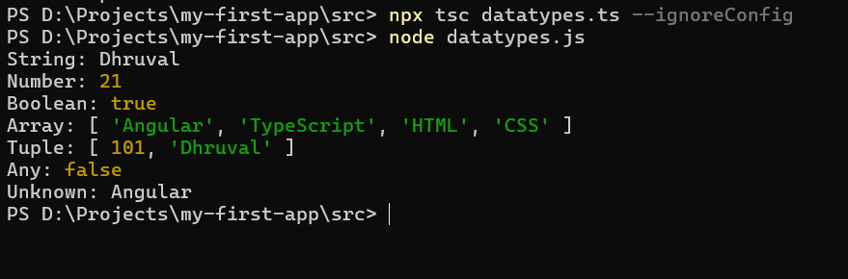

Result
The datatypes.ts file was created successfully. Different TypeScript data types—string, number, boolean, array, tuple, any, and unknown—were declared and initialized. The file was compiled successfully using the TypeScript compiler, and all values were displayed correctly in the terminal using console.log(). Thus, the objective of the assignment was achieved successfully.
Practical - 2 : Create an Interface named IStudent containing studentId, studentName,course, and optional email. Create two student objects and display their details.

Step 1: Open Your Angular Project
Open Visual Studio Code.
Open your Angular project:
my-first-app

Step 2: Create a New TypeScript File
Inside the src folder, create a new file named:
student.ts

Step 3: Write the Following Code
// Interface Definition
interface IStudent {
studentId: number;
studentName: string;
course: string;
email?: string; // Optional property
}

// Student Object 1
let student1: IStudent = {
studentId: 101,
studentName: "Dhruval Gamit",
course: "Angular",
email: "dhruval@example.com"
};

// Student Object 2
let student2: IStudent = {
studentId: 102,
studentName: "Rahul Patel",
course: "TypeScript"
};

// Display Student 1 Details
console.log("Student 1 Details");
console.log("Student ID:", student1.studentId);
console.log("Student Name:", student1.studentName);
console.log("Course:", student1.course);
console.log("Email:", student1.email);

console.log("-----------------------");

// Display Student 2 Details
console.log("Student 2 Details");
console.log("Student ID:", student2.studentId);
console.log("Student Name:", student2.studentName);
console.log("Course:", student2.course);
console.log("Email:", student2.email);

Save the file (Ctrl + S).

Step 4: Open the Terminal
In VS Code, open:
Terminal → New Terminal
or press:
Ctrl + `

Step 5: Go to the src Folder
If you're not already in the src folder, run:
cd src

Step 6: Compile the TypeScript File
Run:
npx tsc student.ts --ignoreConfig

After successful compilation, a file named student.js will be created.

Step 7: Run the Program
Execute:
node student.js

Step 8: Verify the Output
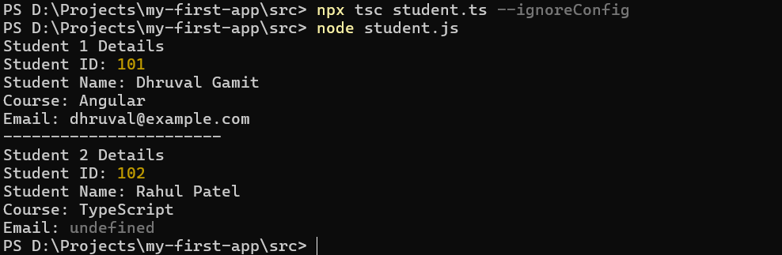

Practical - 2 : Create a Class named Employee with id, name, and salary. Add a constructor and a method named displayEmployee(). Create two employee objects and display their information.

Step 1: Open Your Angular Project
Open Visual Studio Code and open your Angular project:
my-first-app

Step 2: Create a New TypeScript File
Inside the src folder, create a new file named:
employee.ts

Step 3: Write the Following Code
// Employee Class
class Employee {
id: number;
name: string;
salary: number;

// Constructor
constructor(id: number, name: string, salary: number) {
this.id = id;
this.name = name;
this.salary = salary;
}

// Method to Display Employee Details
displayEmployee(): void {
console.log("Employee ID:", this.id);
console.log("Employee Name:", this.name);
console.log("Salary:", this.salary);
console.log("-------------------------");
}
}

// Create Employee Objects
let emp1 = new Employee(101, "Dhruval Gamit", 50000);
let emp2 = new Employee(102, "Rahul Patel", 60000);

// Display Employee Details
console.log("Employee 1 Details");
emp1.displayEmployee();

console.log("Employee 2 Details");
emp2.displayEmployee();

Save the file (Ctrl + S).

Step 4: Open the Terminal
In Visual Studio Code:
Terminal → New Terminal
or press:
Ctrl + `

Step 5: Go to the src Folder
If you're not already in the src folder, run:
cd src

Step 6: Compile the TypeScript File
Run:
npx tsc employee.ts --ignoreConfig

This creates a new file named:
employee.js

Step 7: Run the Program
Execute:
node employee.js

Step 8: Verify the Output
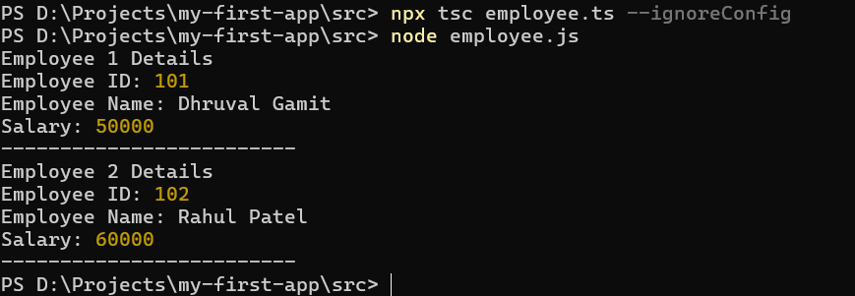

Assignment - 3
Practical - 1: Components & Data Binding.
T1. Create a component called student-card. Add properties name, course,
and isActive in the component class.

Step 1: Open the Terminal
Open the terminal in VS Code.

Step 2: Go to the Project Folder
If you're not already there:
cd D:\Projects\my-first-app

Step 3: Generate the Component
Run:
ng generate component student-card

or the short command:
ng g c student-card

Angular will create:
src
└── app
└── student-card
├── student-card.css
├── student-card.html
├── student-card.spec.ts
└── student-card.ts

Step 4: Open
student-card.ts
import { Component } from '@angular/core';

@Component({
selector: 'app-student-card',
imports: [],
templateUrl: './student-card.html',
styleUrl: './student-card.css'
})
export class StudentCard {

name: string = "Dhruval Gamit";
course: string = "Angular";
isActive: boolean = true;

}

T2. Use Interpolation to display name and course in the template.
Open
student-card.html

<h2>Student Information</h2>

<p>Name: {{ name }}</p>

<p>Course: {{ course }}</p>

Run the project:
ng serve -o

You should see:
Student Information

Name: Dhruval Gamit

Course: Angular

T3. Use Property Binding to disable a button when isActive is false (e.g.,
[disabled]="!isActive").
In
student-card.html

add:
<button [disabled]="!isActive">
Submit
</button>

When
isActive = true;

the button is enabled.
If
isActive = false;

the button becomes disabled.

T4. Use Event Binding to create a button that toggles isActive when clicked
(e.g., (click)="toggleStatus()").
Open
student-card.ts

Add this method:
toggleStatus() {
this.isActive = !this.isActive;
}

Now update
student-card.html

<h2>Student Information</h2>

<p>Name: {{ name }}</p>

<p>Course: {{ course }}</p>

<button [disabled]="!isActive">
Submit
</button>

<br><br>

<button (click)="toggleStatus()">
Toggle Status
</button>

Clicking Toggle Status will enable/disable the Submit button.
T5. Add an input field bound to name using Two-Way Binding with
[(ngModel)]. (Remember to import FormsModule.)

Step 1: Import FormsModule
Open
app.ts

(or app.module.ts if your project is module-based)
If your project is standalone, modify it like this:
import { Component } from '@angular/core';
import { FormsModule } from '@angular/forms';
import { StudentCard } from './student-card/student-card';

@Component({
selector: 'app-root',
imports: [
FormsModule,
StudentCard
],
templateUrl: './app.html',
styleUrl: './app.css'
})
export class App {
}

If you have app.module.ts instead, import FormsModule there under the imports array.

Step 2: Import FormsModule in student-card.ts
Update the component:
import { Component } from '@angular/core';
import { FormsModule } from '@angular/forms';

@Component({
selector: 'app-student-card',
imports: [FormsModule],
templateUrl: './student-card.html',
styleUrl: './student-card.css'
})
export class StudentCard {

name: string = "Dhruval Gamit";
course: string = "Angular";
isActive: boolean = true;

toggleStatus() {
this.isActive = !this.isActive;
}

}

Step 3: Update HTML
student-card.html
<h2>Student Information</h2>

<p>Name: {{ name }}</p>

<p>Course: {{ course }}</p>

<input
type="text"
[(ngModel)]="name"
placeholder="Enter Name">

<br><br>

<button [disabled]="!isActive">
Submit
</button>

<br><br>

<button (click)="toggleStatus()">
Toggle Status
</button>

Step 4: Display the Component
Open
app.html

<app-student-card></app-student-card>

Step 5: Run the Project
ng serve -o

Open: http://localhost:4200
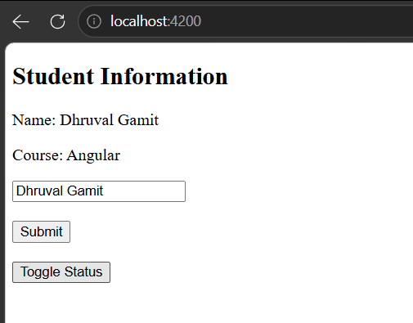
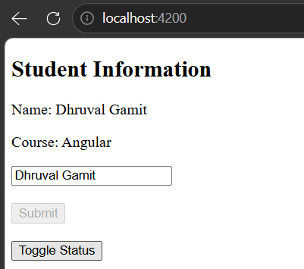

Practical - 2 : Built-in Directives.

D1.Create an array of at least 5 student objects (name, marks). Use *ngFor to
display them in a list, showing the index of each item as well.

Step 1: Open
src/app/student-card/student-card.ts

import { Component } from '@angular/core';
import { CommonModule } from '@angular/common';

@Component({
selector: 'app-student-card',
imports: [CommonModule],
templateUrl: './student-card.html',
styleUrl: './student-card.css'
})
export class StudentCard {

students = [
{ name: 'Dhruval', marks: 85 },
{ name: 'Rahul', marks: 35 },
{ name: 'Priya', marks: 92 },
{ name: 'Amit', marks: 40 },
{ name: 'Neha', marks: 55 }
];

}

Step 2: Open
student-card.html

Add:
<h2>Student List</h2>

<ul>
<li *ngFor="let student of students; let i = index">
{{ i + 1 }}.
{{ student.name }} -
{{ student.marks }}
</li>
</ul>

Run:
ng serve -o

Output
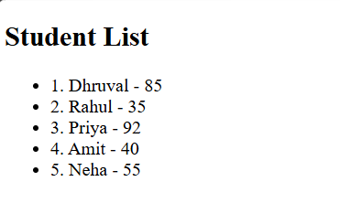

D2.Using *ngIf, show a "Pass" label if a student's marks are greater than 40,
otherwise show "Fail". Use the if/else template syntax (*ngIf="...; else
otherBlock").
Keep the same students array.
<h2>Student List</h2>

<ul>
<li *ngFor="let student of students; let i = index">

{{ i + 1 }}.
{{ student.name }}
-
{{ student.marks }}

<span *ngIf="student.marks > 40; else failBlock">
Pass
</span>

<ng-template #failBlock>
Fail
</ng-template>

</li>
</ul>

Output
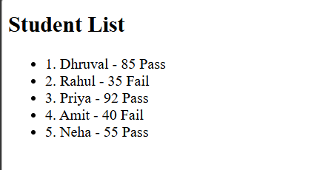

D3.Create a component with a status property ("pending", "approved",
"rejected"). Use [ngSwitch] on a container element and *ngSwitchCase /
*ngSwitchDefault to display a different message for each status.

Step 1
Open
student-card.ts

Add:
status = "approved";

Now the class becomes:
export class StudentCard {

students = [
{ name: 'Dhruval', marks: 85 },
{ name: 'Rahul', marks: 35 },
{ name: 'Priya', marks: 92 },
{ name: 'Amit', marks: 40 },
{ name: 'Neha', marks: 55 }
];

status = "approved";

}

Step 2
At the bottom of student-card.html, add:
<hr>

<h2>Application Status</h2>

<div [ngSwitch]="status">

<p *ngSwitchCase="'pending'">
Your application is Pending.
</p>

<p *ngSwitchCase="'approved'">
Your application is Approved.
</p>

<p *ngSwitchCase="'rejected'">
Your application is Rejected.
</p>

<p *ngSwitchDefault>
Unknown Status
</p>

</div>

Step 3
Change:
status = "approved";

to
status = "pending";

or
status = "rejected";

Run again to see different outputs.

Final Output

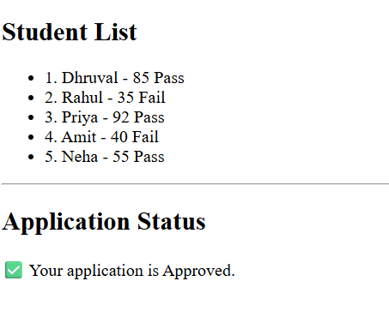

Practical - 3 : Attribute & Custom Directives.

D4.Use Angular's built-in ngStyle and ngClass attribute directives to
dynamically change the background color and add a CSS class to an
element based on a condition.

Step 1: Open
src/app/student-card/student-card.ts

Add the following properties inside the class:
isActive = true;

export class StudentCard {

students = [
{ name: 'Dhruval', marks: 85 },
{ name: 'Rahul', marks: 35 },
{ name: 'Priya', marks: 92 },
{ name: 'Amit', marks: 40 },
{ name: 'Neha', marks: 55 }
];
status = "approved";
isActive = true;
}

Step 2: Open
student-card.css

Add:
.active {
color: white;
font-weight: bold;
padding: 10px;
}

Step 3: Open
student-card.html

Add:
<hr>

<h2>ngStyle and ngClass Example</h2>

<div
[ngStyle]="{'background-color': isActive ? 'green' : 'red'}"
[ngClass]="{'active': isActive}">
Student Status
</div>

When isActive = true, the background becomes green and the CSS class is applied.
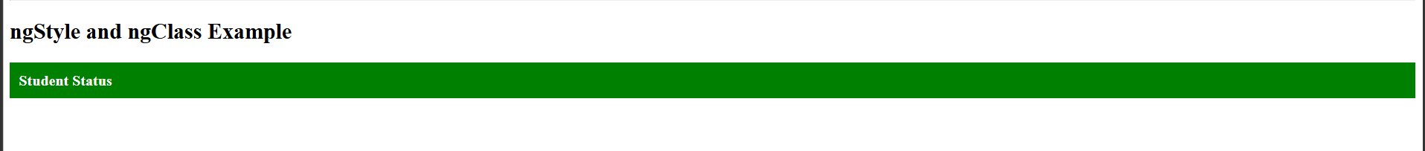
If you change it to:
isActive = false;
the background becomes red.
D5.Generate a custom attribute directive called appHighlight using ng
generate directive highlight. Make it change an element's background
color to yellow on mouseenter and revert it on mouseleave (use
@HostListener).

Step 1: Open the Terminal
Go to your project folder:
cd D:\Projects\my-first-app

Step 2: Generate the Directive
Run:
ng generate directive highlight

or
ng g d highlight

Angular creates:
src
└── app
└── highlight.ts

Step 3: Open the Directive File
Replace everything with:
import { Directive, ElementRef, HostListener } from '@angular/core';

@Directive({
selector: '[appHighlight]'
})
export class Highlight {

constructor(private element: ElementRef) { }

@HostListener('mouseenter')
onMouseEnter() {
this.element.nativeElement.style.backgroundColor = 'yellow';
}

@HostListener('mouseleave')
onMouseLeave() {
this.element.nativeElement.style.backgroundColor = '';
}

}

Step 4: Import the Directive
Open
student-card.ts

Import the directive:
import { Highlight } from '../highlight';

Then update the component decorator:
@Component({
selector: 'app-student-card',
imports: [CommonModule, Highlight],
templateUrl: './student-card.html',
styleUrl: './student-card.css'
})

D6.Apply your appHighlight directive to at least two different elements in a
template and confirm the hover effect works.
Open
student-card.html

Add:
<hr>

<h2>Custom Directive Example</h2>

<h3 appHighlight>
Welcome to Angular
</h3>

<p appHighlight>
Hover over this paragraph to highlight it.
</p>

Step 5: Run the Project
ng serve -o

Result
When you move the mouse over:
Welcome to Angular
its background becomes yellow.
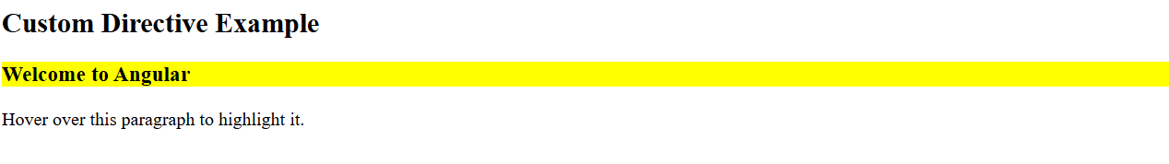

When you move the mouse away, it returns to its original background.
The same behavior occurs for:
Hover over this paragraph to highlight it.
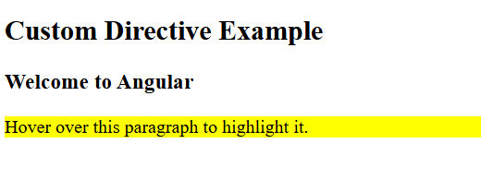

Practical - 4 : Pipes.

P1.Display today's date in three different formats using the built-in date pipe
(e.g., 'short', 'fullDate', 'dd/MM/yyyy').

Step 1: Open
src/app/student-card/student-card.ts

Add the following property inside the class:
today = new Date();

Step 2: Open
student-card.html

Add:
<hr>

<h2>Date Pipe Example</h2>

<p>Short Date: {{ today | date:'short' }}</p>

<p>Full Date: {{ today | date:'fullDate' }}</p>

<p>Custom Date: {{ today | date:'dd/MM/yyyy' }}</p>

Output:
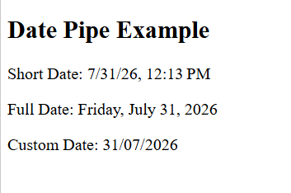

P2.Display a price value using the currency pipe, formatted in USD and INR.

Step 1
Open
student-card.ts

Add:
price = 25000;

Step 2
Open
student-card.html

Add:
<hr>

<h2>Currency Pipe Example</h2>

<p>USD: {{ price | currency:'USD' }}</p>

<p>INR: {{ price | currency:'INR' }}</p>

Output:
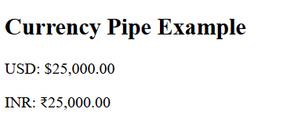

P3.Take a string property (e.g., a student's name) and display it using the
uppercase and lowercase pipes.

Step 1
Open
student-card.ts

Add:
studentName = "Dhruval Gamit";

Step 2
Open
student-card.html

Add:
<hr>

<h2>Uppercase & Lowercase Pipe</h2>

<p>Original: {{ studentName }}</p>

<p>Uppercase: {{ studentName | uppercase }}</p>

<p>Lowercase: {{ studentName | lowercase }}</p>

Output:
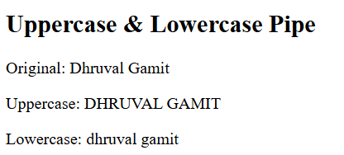

P4.Create a custom pipe called truncateText that shortens a long string to a
given number of characters and appends "...". Use ng generate pipe
truncateText, implement the transform() method, and use it in a template.

Step 1: Generate the Pipe
Open the terminal.
Go to your project folder:
cd D:\Projects\my-first-app

Run:
ng generate pipe truncateText

or
ng g p truncateText

Angular creates a file similar to:
src
└── app
└── truncate-text.pipe.ts

Step 2: Open
truncate-text.pipe.ts

import { Pipe, PipeTransform } from '@angular/core';

@Pipe({
name: 'truncateText'
})
export class TruncateTextPipe implements PipeTransform {

transform(value: string, limit: number): string {

if (!value) {
return '';
}

if (value.length <= limit) {
return value;
}

return value.substring(0, limit) + '...';
}

}

Step 3: Import the Pipe
Open
student-card.ts

Import the pipe:
import { TruncateTextPipe } from '../truncate-text.pipe';

Then update the imports array:
@Component({
selector: 'app-student-card',
imports: [
CommonModule,
Highlight,
TruncateTextPipe
],
templateUrl: './student-card.html',
styleUrl: './student-card.css'
})

Step 4
Open
student-card.ts

Add:
description = "Angular is a powerful front-end framework developed by Google for building modern web applications.";

Step 5
Open
student-card.html

Add:
<hr>

<h2>Custom Pipe Example</h2>

<p>Original:</p>

<p>{{ description }}</p>

<p>Truncated:</p>

<p>{{ description | truncateText:30 }}</p>

Step 6: Run the Project
ng serve -o

Output:
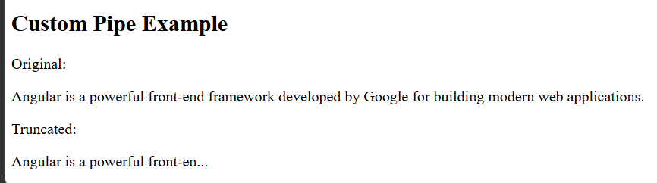

Assignment - 4

Practical - 1 :Template-driven Forms

T1.Import FormsModule into your app. Create a component called login-
template with a simple login form (email and password fields) using
ngModel for two-way binding.

Step 1: Generate the Component
Open the terminal in your project folder:
cd D:\Projects\my-first-app

Run:
ng generate component login-template

or
ng g c login-template

Step 2: Import FormsModule
Open:
src/app/login-template/login-template.ts

Replace it with:
import { Component } from '@angular/core';
import { FormsModule } from '@angular/forms';

@Component({
selector: 'app-login-template',
imports: [FormsModule],
templateUrl: './login-template.html',
styleUrl: './login-template.css'
})
export class LoginTemplate {

email = '';
password = '';

}

T2.Add the name attribute to each input and wrap the form in ngForm. On
submit, log the form's value to the console using (ngSubmit).
Open:
src/app/login-template/login-template.html

<h2>Login Form</h2>

<form #loginForm="ngForm" (ngSubmit)="onSubmit(loginForm)">

<label>Email:</label>
<br>

<input
type="email"
name="email"
[(ngModel)]="email">

<br><br>

<label>Password:</label>
<br>

<input
type="password"
name="password"
[(ngModel)]="password">

<br><br>

<button type="submit">
Login
</button>

</form>

Step 3: Add Submit Method
Open:
login-template.ts

Add:
import { NgForm } from '@angular/forms';

Then add this method inside the class:
onSubmit(form: NgForm) {
console.log(form.value);
}

The class should now contain:
email = '';
password = '';

onSubmit(form: NgForm) {
console.log(form.value);
}

T3.Apply built-in validators (required, email, minlength) to the form fields and
disable the Submit button until the form is valid.

<h2>Login Form</h2>

<form #loginForm="ngForm" (ngSubmit)="onSubmit(loginForm)">

<label>Email:</label>
<br>

<input
type="email"
name="email"
[(ngModel)]="email"
required
email
#emailField="ngModel">

<br><br>

<label>Password:</label>
<br>

<input
type="password"
name="password"
[(ngModel)]="password"
required
minlength="6"
#passwordField="ngModel">

<br><br>

<button
type="submit"
[disabled]="loginForm.invalid">
Login
</button>

</form>

Now the Login button stays disabled until:
- Email is entered.
- Email is valid.
- Password is entered.
- Password has at least 6 characters.

T4.Display an inline error message below each field when it is touched and
invalid (e.g., "Email is required").

<h2>Login Form</h2>

<form #loginForm="ngForm" (ngSubmit)="onSubmit(loginForm)">

<label>Email:</label>
<br>

<input
type="email"
name="email"
[(ngModel)]="email"
required
email
#emailField="ngModel">

<div *ngIf="emailField.invalid && emailField.touched">

<small *ngIf="emailField.errors?.['required']">
Email is required.
</small>

<small *ngIf="emailField.errors?.['email']">
Enter a valid email.
</small>

</div>

<br>

<label>Password:</label>
<br>

<input
type="password"
name="password"
[(ngModel)]="password"
required
minlength="6"
#passwordField="ngModel">

<div *ngIf="passwordField.invalid && passwordField.touched">

<small *ngIf="passwordField.errors?.['required']">
Password is required.
</small>

<small *ngIf="passwordField.errors?.['minlength']">
Password must be at least 6 characters.
</small>

</div>

<br>

<button
type="submit"
[disabled]="loginForm.invalid">
Login
</button>

</form>

Step 5. Display the Component
Open:
src/app/app.html

<app-login-template></app-login-template>

Step 6. Import the Component into the Root Component
Open:
src/app/app.ts

Import the component:
import { LoginTemplate } from './login-template/login-template';

Then update the imports array:
@Component({
selector: 'app-root',
imports: [LoginTemplate],
templateUrl: './app.html',
styleUrl: './app.css'
})

Step 7. Run the Project
ng serve -o

Open:
http://localhost:4200

Final Output:

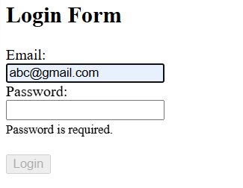

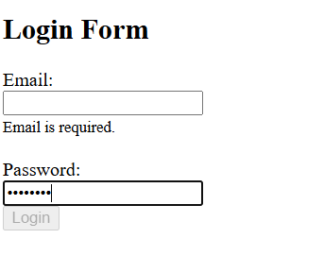
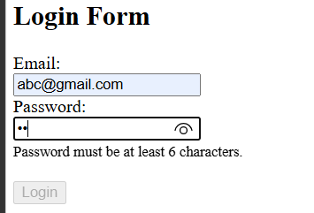

Practical - 2 :Reactive Forms

R1.Import ReactiveFormsModule. Create a component called registration-
reactive and build the same form (name, email, password) using FormGroup and FormControl directly in the TypeScript file.

Step 1: Generate the Component
Open the terminal:
ng g c registration-reactive

Step 2: Open
src/app/registration-reactive/registration-reactive.ts

import { Component } from '@angular/core';
import { ReactiveFormsModule, FormGroup, FormControl, Validators } from '@angular/forms';
import { CommonModule } from '@angular/common';

@Component({
selector: 'app-registration-reactive',
imports: [ReactiveFormsModule, CommonModule],
templateUrl: './registration-reactive.html',
styleUrl: './registration-reactive.css'
})
export class RegistrationReactive {

registrationForm = new FormGroup({

name: new FormControl('', [
Validators.required
]),

email: new FormControl('', [
Validators.required,
Validators.email
]),

password: new FormControl('', [
Validators.required,
Validators.minLength(6)
])

});

onSubmit() {
console.log(this.registrationForm.value);
}}

R2.Refactor the form from R1 to use FormBuilder instead of manually
creating each FormControl. Apply the same built-in validators (required,
email, minlength).

import { Component } from '@angular/core';
import {
ReactiveFormsModule,
FormBuilder,
FormGroup,
Validators
} from '@angular/forms';
import { CommonModule } from '@angular/common';

@Component({
selector: 'app-registration-reactive',
imports: [ReactiveFormsModule, CommonModule],
templateUrl: './registration-reactive.html',
styleUrl: './registration-reactive.css'
})
export class RegistrationReactive {

registrationForm!: FormGroup;

constructor(private fb: FormBuilder) {
this.registrationForm = this.fb.group({
name: ['', Validators.required],
email: ['', [Validators.required, Validators.email]],
password: ['', [Validators.required, Validators.minLength(6)]]
});
}

onSubmit() {
console.log(this.registrationForm.value);
}

}

R3.Bind the FormGroup to the template using [formGroup] and
formControlName, and display validation error messages conditionally
based on control state (touched, invalid, errors).
registration-reactive.html

<h2>Registration Form</h2>

<form
[formGroup]="registrationForm"
(ngSubmit)="onSubmit()">

<label>Name</label>
<br>

<input
type="text"
formControlName="name">

<div *ngIf="registrationForm.get('name')?.touched &&
registrationForm.get('name')?.invalid">

<small *ngIf="registrationForm.get('name')?.errors?.['required']">
Name is required.
</small>

</div>

<br><br>

<label>Email</label>
<br>

<input
type="email"
formControlName="email">

<div *ngIf="registrationForm.get('email')?.touched &&
registrationForm.get('email')?.invalid">

<small *ngIf="registrationForm.get('email')?.errors?.['required']">
Email is required.
</small>

<small *ngIf="registrationForm.get('email')?.errors?.['email']">
Enter a valid email.
</small>

</div>

<br><br>

<label>Password</label>
<br>
<input
type="password"
formControlName="password">

<div *ngIf="registrationForm.get('password')?.touched &&
registrationForm.get('password')?.invalid">

<small *ngIf="registrationForm.get('password')?.errors?.['required']">
Password is required.
</small>

<small *ngIf="registrationForm.get('password')?.errors?.['minlength']">
Password must be at least 6 characters.
</small>

</div>

<br><br>

<button
type="submit"
[disabled]="registrationForm.invalid">
Register
</button>
</form>

Step 4. Display the Component
Open
src/app/app.html

Replace everything with:
<app-registration-reactive></app-registration-reactive>

Step 5. Import the Component
Open
src/app/app.ts
Import:
import { RegistrationReactive } from './registration-reactive/registration-reactive';

Update the component:
@Component({
selector: 'app-root',
imports: [RegistrationReactive],
templateUrl: './app.html',
styleUrl: './app.css'
})

Step 6. Run the Project
ng serve -o

Test the Form
Try these cases:

Case 1
Leave everything empty.
Click inside each field, then click outside.
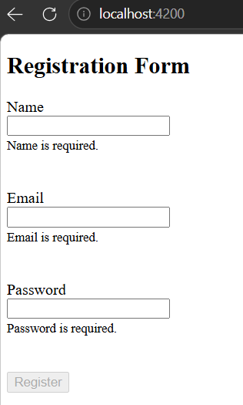
You should see:

Case 2
Email:
abc

You should see:
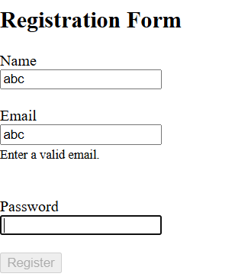

Case 3
Password:
123

You should see:
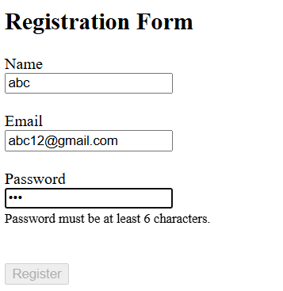

Case 4

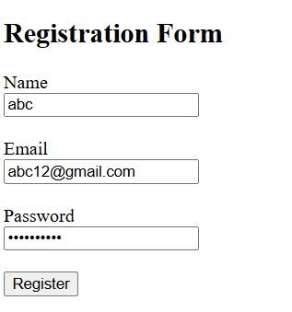
The Register button becomes enabled.
Click Register.
Open F12 → Console.
You should see:
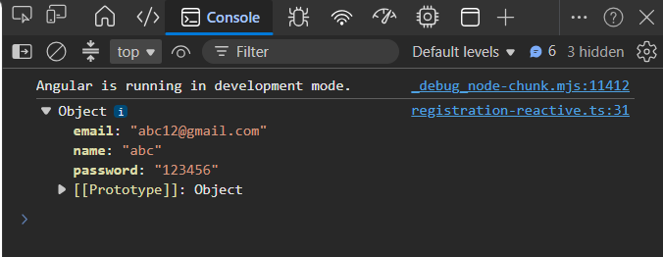

Practical - 3 :Custom & Cross-field Validation

V1.Write a custom validator function noWhitespaceValidator that rejects a
value containing only spaces (or any spaces, your choice), and apply it to
the username field of your Reactive Form.

Step 1: Create a Validator File
Inside:
src/app

Create a new file:
validators.ts

Step 2: Add the Validator
Paste this code into validators.ts:
import { AbstractControl, ValidationErrors } from '@angular/forms';

export function noWhitespaceValidator(
control: AbstractControl
): ValidationErrors | null {

const value = control.value;

if (!value) {
return null;
}

if (value.trim().length === 0) {
return { whitespace: true };
}

return null;
}

Step 3: Import the Validator
Open:
registration-reactive.ts

Add:
import { noWhitespaceValidator } from '../validators';

Step 4: Apply It
Change the name control to:
name: [
'',
[
Validators.required,
noWhitespaceValidator
]
],

Step 5: Show the Error
In registration-reactive.html
Below the Name input, add:
<small
*ngIf="registrationForm.get('name')?.errors?.['whitespace']
&& registrationForm.get('name')?.touched">

Name cannot contain only spaces.

</small>

Test
Enter
" "

Only spaces.
You should see:
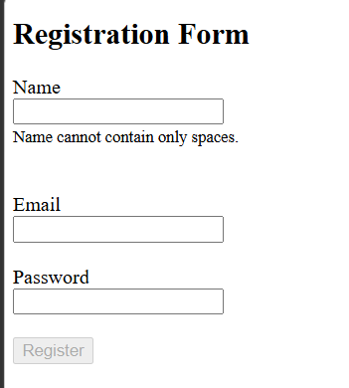

V2.Add a Confirm Password field to your registration form and implement
Cross-field Validation so the form is invalid if Password and Confirm
Password don't match. Display an appropriate error message.

Step 1: Create Another Validator
Open
validators.ts

Add this below the first validator:
import { FormGroup, ValidationErrors } from '@angular/forms';

export function passwordMatchValidator(
form: FormGroup
): ValidationErrors | null {

const password = form.get('password')?.value;

const confirmPassword =
form.get('confirmPassword')?.value;

if (password === confirmPassword) {
return null;
}

return {
passwordMismatch: true
};
}

Step 2: Import It
Open
registration-reactive.ts

Add
import {
noWhitespaceValidator,
passwordMatchValidator
} from '../validators';

Step 3: Add Confirm Password
Update your form:
this.registrationForm = this.fb.group({

name: [
'',
[
Validators.required,
noWhitespaceValidator
]
],

email: [
'',
[
Validators.required,
Validators.email
]
],

password: [
'',
[
Validators.required,
Validators.minLength(6)
]
],

confirmPassword: [
'',
[
Validators.required
]
]

},
{
validators: passwordMatchValidator
});

Step 4: Add Confirm Password Input
In
registration-reactive.html

Below Password add
<br><br>

<label>Confirm Password</label>

<br>

<input
type="password"
formControlName="confirmPassword">

<div
*ngIf="
registrationForm.get('confirmPassword')?.touched
&&
registrationForm.get('confirmPassword')?.invalid">

<small
*ngIf="
registrationForm.get('confirmPassword')
?.errors?.['required']">

Confirm Password is required.

</small>

</div>

Step 5: Show Password Mismatch Error
Below the Confirm Password section add
<div
*ngIf="
registrationForm.errors?.['passwordMismatch']
&&
registrationForm.get('confirmPassword')?.touched">

<small>

Passwords do not match.

</small>

</div>

Output:

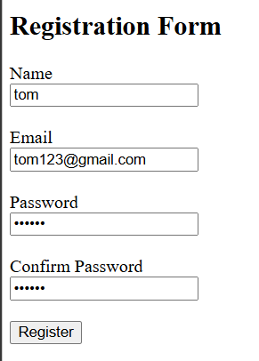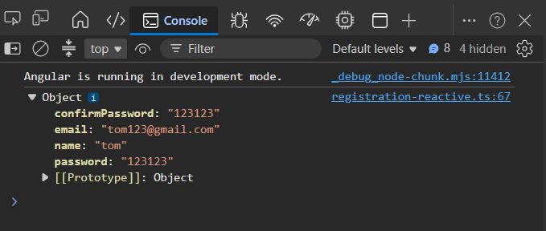

Practical - 4 :Dynamic Forms

F1.Build a "Skills" section using FormArray where a user can dynamically add
or remove skill input fields with Add/Remove buttons.

Step 1: Import FormArray

registration-reactive.ts

Update the imports:
import {
ReactiveFormsModule,
FormBuilder,
FormGroup,
FormArray,
Validators
} from '@angular/forms';

Step 2: Add Skills FormArray
Inside the constructor, update the form:
this.registrationForm = this.fb.group({

name: [
'',
[
Validators.required,
noWhitespaceValidator
]
],

email: [
'',
[
Validators.required,
Validators.email
]
],

password: [
'',
[
Validators.required,
Validators.minLength(6)
]
],

confirmPassword: [
'',
Validators.required
],

skills: this.fb.array([
this.fb.control('')
])

},
{
validators: passwordMatchValidator
});

Step 3: Create Getter
Inside the class add:
get skills(): FormArray {
return this.registrationForm.get('skills') as FormArray;
}

Step 4: Add Skill Method
addSkill() {
this.skills.push(this.fb.control(''));
}

Step 5: Remove Skill Method
removeSkill(index: number) {

if (this.skills.length > 1) {
this.skills.removeAt(index);
}

}

F2.Submit the dynamic form and log the full array of entered skills to the
console. Confirm the array updates correctly as fields are added/removed.

registration-reactive.html

Add this section before the Register button.
<hr>

<h3>Skills</h3>

<div formArrayName="skills">

<div *ngFor="let skill of skills.controls; let i = index">

<input
type="text"
[formControlName]="i"
placeholder="Enter Skill">

<button
type="button"
(click)="removeSkill(i)">
Remove
</button>

<br><br>

</div>

</div>

<button
type="button"
(click)="addSkill()">
Add Skill
</button>

<br><br>

Step 6: Update Submit Method
onSubmit() {

console.log("Complete Form");

console.log(this.registrationForm.value);

console.log("Skills");

console.log(this.skills.value);

}

Step 7: Run
ng serve -o

Output:
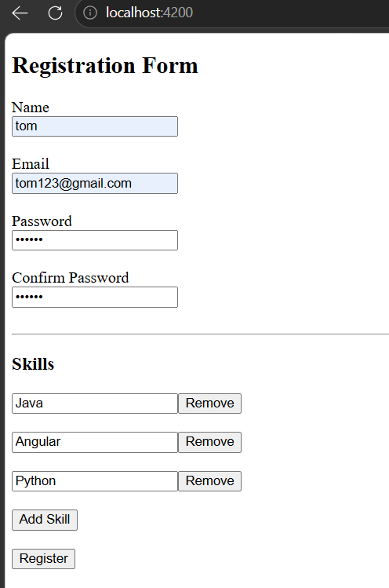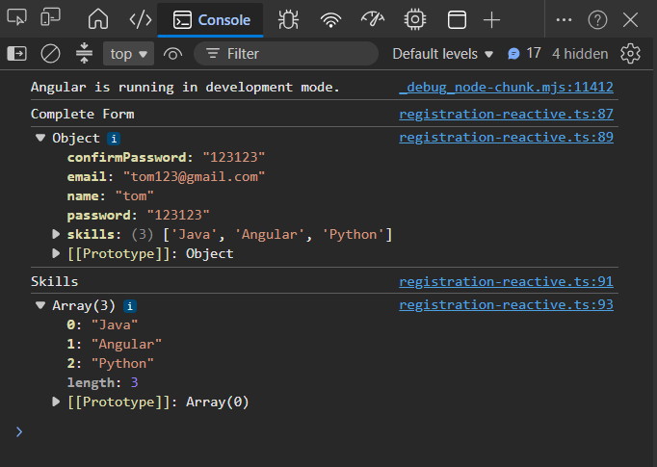
Assignment - 5

Practical - 1 :Router Setup & Route Configuration
T1.Set up a standalone Angular app with routing using provideRouter in bootstrapApplication. Create three components: Home, About, and Contact.

Open the terminal in your project folder.
Run:
ng g c home

ng g c about

ng g c contact

ng g c page-not-found

You should now have:
src/app
│
├── home
├── about
├── contact
└── page-not-found

T2.Define routes for '', 'about', and 'contact' mapping to the three components above. Add a RouterOutlet in your root component template.

Step 1: Create app.routes.ts
Inside src/app, create a file named:
app.routes.ts

Add:
import { Routes } from '@angular/router';

import { Home } from './home/home';
import { About } from './about/about';
import { Contact } from './contact/contact';
import { PageNotFound } from './page-not-found/page-not-found';

export const routes: Routes = [

{
path: '',
component: Home
},

{
path: 'about',
component: About
},

{
path: 'contact',
component: Contact
},

{
path: '**',
component: PageNotFound
}

];

Step 2: Configure app.config.ts
Open
src/app/app.config.ts

Replace with:
import { ApplicationConfig } from '@angular/core';
import { provideRouter } from '@angular/router';

import { routes } from './app.routes';

export const appConfig: ApplicationConfig = {
providers: [
provideRouter(routes)
]
};

Step 3: Check main.ts
It should contain:
import { bootstrapApplication } from '@angular/platform-browser';

import { appConfig } from './app/app.config';

import { App } from './app/app';

bootstrapApplication(App, appConfig)
.catch(err => console.error(err));

If your project was created with routing enabled, this is already correct.

T3.Build a navigation bar using routerLink for each of the three routes, and add routerLinkActive to highlight the currently active link.
Open
app.ts

Import RouterModule:
import { RouterModule } from '@angular/router';

Then
@Component({
selector: 'app-root',
imports: [
RouterModule
],
templateUrl: './app.html',
styleUrl: './app.css'
})
Open
app.html

Replace everything with:
<h1>Angular Routing Demo</h1>

<nav>

<a
routerLink=""
routerLinkActive="active"
[routerLinkActiveOptions]="{ exact: true }">
Home
</a>

|

<a
routerLink="/about"
routerLinkActive="active">
About
</a>

|

<a
routerLink="/contact"
routerLinkActive="active">
Contact
</a>

</nav>

<hr>

<router-outlet></router-outlet>

T4.Add a wildcard route ('**') that loads a PageNotFoundComponent, and confirm it only triggers for undefined URLs.
Open
app.css

Add:
nav a{
text-decoration:none;
margin-right:15px;
color:black;
}

.active{
color:red;
font-weight:bold;
}

Step 5. Edit Home Component
Open
home.html

<h2>Home Page</h2>

<p>Welcome to the Home Page.</p>

Step 6. Edit About Component
Open
about.html

<h2>About Page</h2>

<p>This is the About Page.</p>

Step 7. Edit Contact Component
Open
contact.html

<h2>Contact Page</h2>

<p>This is the Contact Page.</p>

Step 8. Edit Page Not Found
Open
page-not-found.html
<h2>404</h2>
<p>Page Not Found</p>

Step 9. Run
ng serve -o

Output:
Visit
http://localhost:4200

Home

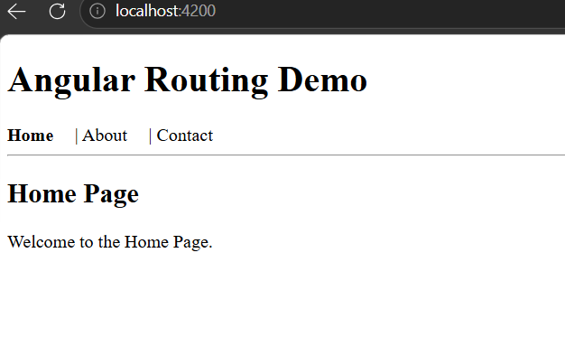

About
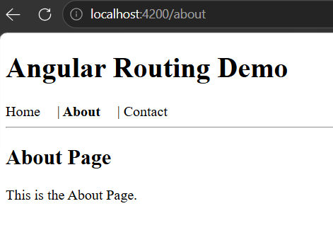

Contact
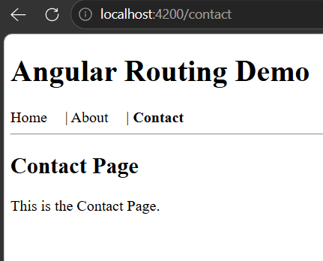

Wildcard Route
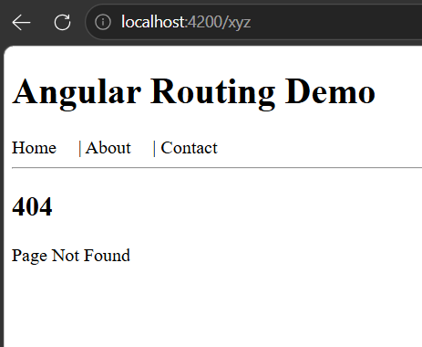

This confirms the wildcard route (**) only handles undefined URLs.

Practical - 2 : Route Parameters & Query Parameters
P1.Create a UserComponent and configure a route 'users/:id'. Use ActivatedRoute and paramMap to read the id and display it in the template.

Step 1: Generate the Component
Open the terminal and run:
ng g c user

Step 2: Add the Route
Open:
src/app/app.routes.ts
Add this route before the wildcard (**) route:
{
path: 'users/:id',
component: User
},

Import the component at the top:
import { User } from './user/user';

Your routes should now look like:
export const routes: Routes = [
{ path: '', component: Home },
{ path: 'about', component: About },
{ path: 'contact', component: Contact },
{ path: 'users/:id', component: User },
{ path: '**', component: PageNotFound }
];

Step 3: Update user.ts
Replace it with:
import { Component } from '@angular/core';
import { ActivatedRoute } from '@angular/router';

@Component({
selector: 'app-user',
imports: [],
templateUrl: './user.html',
styleUrl: './user.css'
})
export class User {
userId: string | null = '';
constructor(private route: ActivatedRoute) {

this.route.paramMap.subscribe(params => {
this.userId = params.get('id');
});
}}

Step 4: Update user.html
<h2>User Details</h2>
<p>User ID: {{ userId }}</p>

P2.Create a list of at least 5 users with routerLink directives that navigate to /users/:id for each one, and confirm the correct id displays when clicked.
We'll use the Home component.

Step 1: Open
home.ts

Replace with:
import { Component } from '@angular/core';
import { RouterModule } from '@angular/router';
import { CommonModule } from '@angular/common';

@Component({
selector: 'app-home',
imports: [RouterModule, CommonModule],
templateUrl: './home.html',
styleUrl: './home.css'
})
export class Home {

users = [
{ id: 1, name: 'Dhruval' },
{ id: 2, name: 'Rahul' },
{ id: 3, name: 'Priya' },
{ id: 4, name: 'Amit' },
{ id: 5, name: 'Neha' }
];}

Step 2: Open
home.html
<h2>User List</h2>
<ul>
<li *ngFor="let user of users">
<a [routerLink]="['/users', user.id]">
{{ user.name }}
</a>
</li>
</ul>

Step 3: Run
ng serve -o
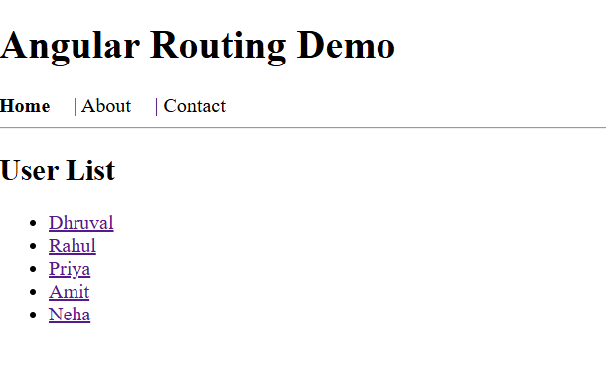
Output:
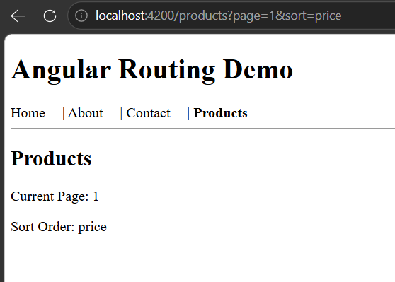
P3.Build a ProductsComponent with pagination controls. Use query parameters (e.g., ?page=2&sort=price) and queryParamMap to read and display the current page and sort order.

Step 1: Generate Component
ng g c products

Step 2: Add Route
In app.routes.ts
import { Products } from './products/products';
Add
{
path: 'products',
component: Products
},

before the wildcard route.

Step 3: Update products.ts
import { Component } from '@angular/core';
import { ActivatedRoute } from '@angular/router';

@Component({
selector: 'app-products',
imports: [],
templateUrl: './products.html',
styleUrl: './products.css'
})
export class Products {

page = '';
sort = '';

constructor(private route: ActivatedRoute) {

this.route.queryParamMap.subscribe(params => {

this.page = params.get('page') ?? '1';
this.sort = params.get('sort') ?? 'default';
});
}
}

Step 4: Update products.html
<h2>Products</h2>
<p>Current Page: {{ page }}</p>
<p>Sort Order: {{ sort }}</p>

Step 5: Add Link to Navigation
Open:
app.html
Add:
|
<a
routerLink="/products"
[queryParams]="{page:1,sort:'price'}"
routerLinkActive="active">
Products
</a>
Your navigation becomes:
Home | About | Contact | Products

Output:


Practical - 3 : Child Routes
C1.Build a simple Dashboard layout with a DashboardComponent containing its own RouterOutlet, and configure child routes for Users, Orders, and Settings.
C2.Add navigation links inside the dashboard for each child route and confirm the parent layout (header/sidebar) stays visible while only the child outlet content changes.

Step 1. Create Components
Open the terminal.
Run:
ng g c dashboard

ng g c dashboard/users

ng g c dashboard/orders

ng g c dashboard/settings

Your project should now contain:
src/app
│
├── dashboard
│ ├── dashboard.ts
│ ├── dashboard.html
│ │
│ ├── users
│ ├── orders
│ └── settings

Step 2. Configure Child Routes
Open:
src/app/app.routes.ts

Import:
import { Dashboard } from './dashboard/dashboard';
import { Users } from './dashboard/users/users';
import { Orders } from './dashboard/orders/orders';
import { Settings } from './dashboard/settings/settings';

Add this route before the wildcard route:
{
path: 'dashboard',
component: Dashboard,
children: [

{
path: 'users',
component: Users
},

{
path: 'orders',
component: Orders
},

{
path: 'settings',
component: Settings
},

{
path: '',
redirectTo: 'users',
pathMatch: 'full'
}

]
},

Step 3. Update Dashboard Component

dashboard.ts

import { Component } from '@angular/core';
import { RouterModule } from '@angular/router';

@Component({
selector: 'app-dashboard',
imports: [RouterModule],
templateUrl: './dashboard.html',
styleUrl: './dashboard.css'
})
export class Dashboard {

}

Step 4. Create Dashboard Layout

dashboard.html

Replace with:
<h2>Dashboard</h2>

<hr>

<nav>

<a
routerLink="users"
routerLinkActive="active">
Users
</a>

|

<a
routerLink="orders"
routerLinkActive="active">
Orders
</a>

|

<a
routerLink="settings"
routerLinkActive="active">
Settings
</a>

</nav>

<hr>

<router-outlet></router-outlet>

Step 5. Import RouterModule
- dashboard/users/users.ts
- dashboard/orders/orders.ts
- dashboard/settings/settings.ts

users.ts
import { Component } from '@angular/core';

@Component({
selector: 'app-users',
imports: [],
templateUrl: './users.html',
styleUrl: './users.css'
})
export class Users {

}

orders.ts
import { Component } from '@angular/core';

@Component({
selector: 'app-orders',
imports: [],
templateUrl: './orders.html',
styleUrl: './orders.css'
})
export class Orders {

}

settings.ts
import { Component } from '@angular/core';

@Component({
selector: 'app-settings',
imports: [],
templateUrl: './settings.html',
styleUrl: './settings.css'
})
export class Settings {

}

Step 6. Update HTML Files

users.html
<h3>Users Page</h3>

<p>This is the Users section.</p>

orders.html
<h3>Orders Page</h3>

<p>This is the Orders section.</p>

settings.html
<h3>Settings Page</h3>

<p>This is the Settings section.</p>

Step 7. Add Dashboard Link
Open:
app.html

Add:
|

<a
routerLink="/dashboard"
routerLinkActive="active">

Dashboard

</a>

Now your navigation becomes:
Home | About | Contact | Products | Dashboard

Step 8. Run
ng serve -o

Output:
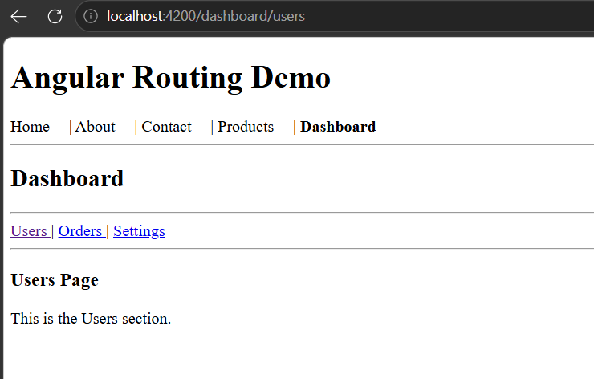

Practical - 4 : Lazy Loading
L1.Convert your About or Contact route to use loadComponent for lazy loading, and verify (using browser dev tools network tab) that its chunk loads only when the route is visited.

Step 1: Open app.routes.ts
Locate the About route.
It currently looks like:
{
path: 'about',
component: About
},

Replace it with:
{
path: 'about',
loadComponent: () =>
import('./about/about').then(m => m.About)
},

Step 2: Remove the Import
At the top of app.routes.ts, remove:
import { About } from './about/about';

The About component is now loaded only when needed.

Step 3: Run the Project
ng serve -o

Step 4: Verify Lazy Loading
- Open Google Chrome.
- Press F12.
- Open the Network tab.
- Check Disable cache (optional but recommended).
- Refresh the page.
- Notice that the About component's JavaScript chunk is not loaded.
- Click the About link.
A new JavaScript chunk for the About component will appear in the Network tab, confirming that it was loaded only when you navigated to that route.

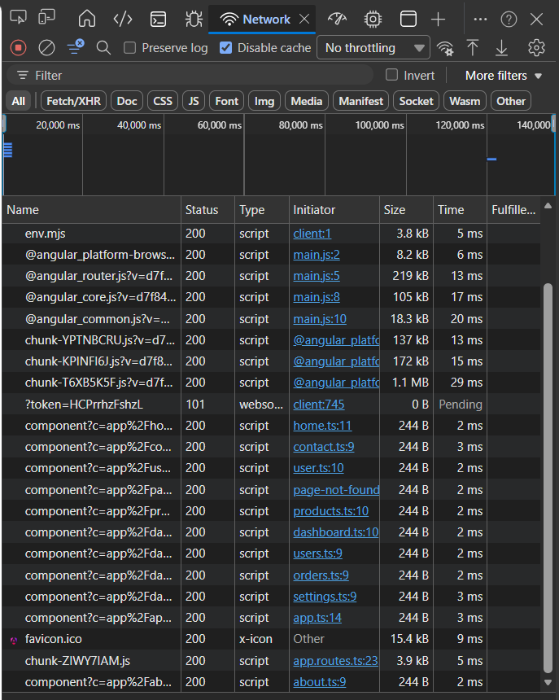
Output: (Before clicking About) (After Clicking About)
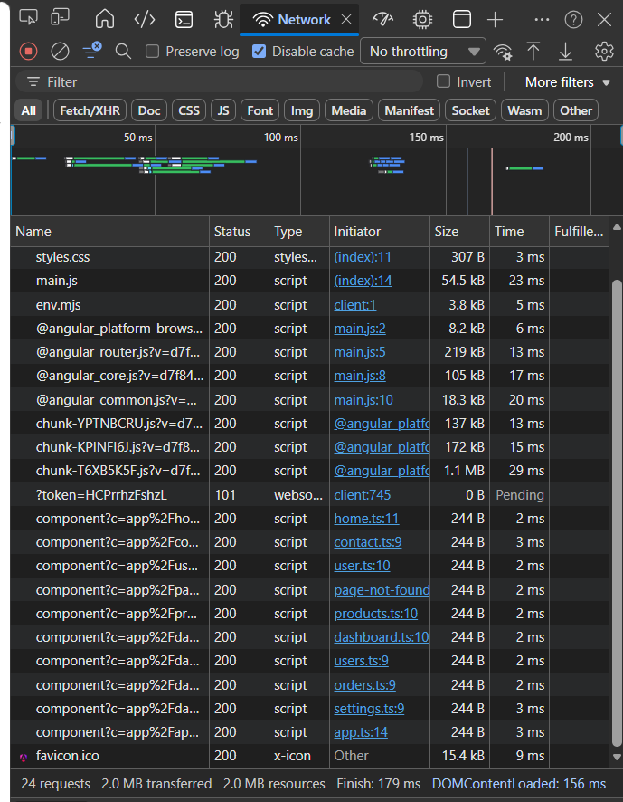

L2.Create a small 'Reports' feature with its own route file and load it using loadChildren at the feature level.

Step 1: Create the Reports Component
Run:
ng g c reports

Step 2: Create a Routes File
Create a new file:
src/app/reports.routes.ts

Add:
import { Routes } from '@angular/router';
import { Reports } from './reports/reports';

export const REPORT_ROUTES: Routes = [

{
path: '',
component: Reports
}

];

Step 3: Update app.routes.ts
Add this route before the wildcard route:
{
path: 'reports',
loadChildren: () =>
import('./reports.routes').then(m => m.REPORT_ROUTES)
},

Step 4: Update reports.html
<h2>Reports</h2>

<p>Welcome to the Reports Feature.</p>

Step 5: Add Navigation Link
Open:
app.html

Add:
|

<a
routerLink="/reports"
routerLinkActive="active">

Reports

</a>

Now your navigation bar looks like:
Home | About | Contact | Products | Dashboard | Reports

Step 6: Run
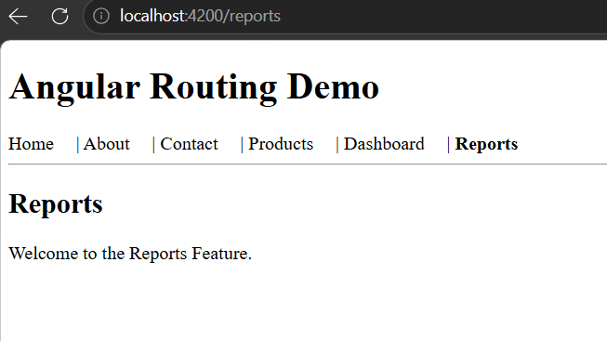
ng serve -o

Verify loadChildren
- Open Developer Tools (F12).
- Go to the Network tab.
- Refresh the application.
- The Reports feature chunk is not downloaded initially.
- Click Reports.
- A new JavaScript chunk (for the Reports feature) appears in the Network tab, showing that the feature was loaded on demand.

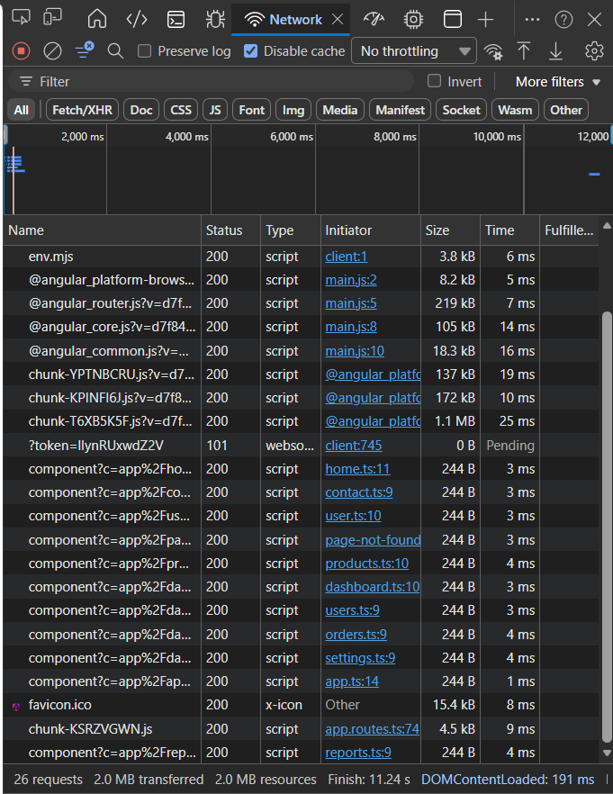
Output: (Before clicking Reports) (After Clicking Reports)
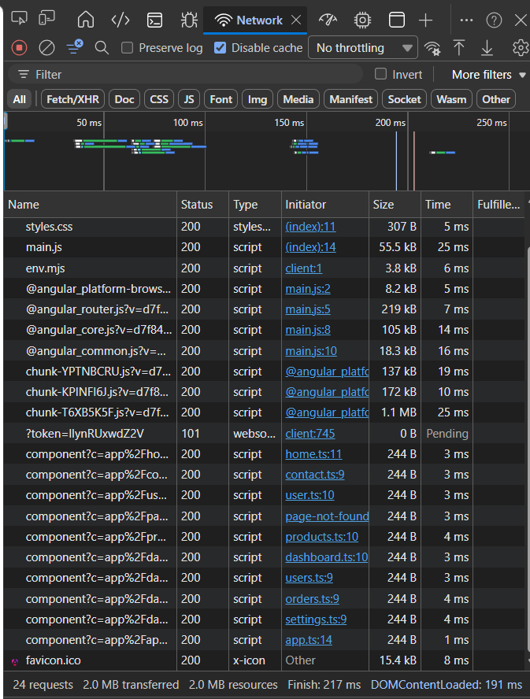

Practical - 5 : Route Guards (AuthGuard)
G1.Create a simple AuthService with an isLoggedIn() method (you can hardcode it to return true/false for testing or toggle it with a button).

Step 1: Generate the Service
Open the terminal:
ng g s auth

This creates:
src/app/auth.ts

Step 2: Update auth.ts
import { Injectable } from '@angular/core';
@Injectable({
providedIn: 'root'
})
export class Auth {
loggedIn = false;
isLoggedIn(): boolean {
return this.loggedIn;
}
login() {
this.loggedIn = true;
}
logout() {
this.loggedIn = false;
}}
G2.Implement an authGuard using CanActivateFn that calls AuthService.isLoggedIn(), and apply it to a protected 'profile' route using canActivate.

Generate it:
ng g c profile

Update profile.html
<h2>Profile Page</h2>
<p>Welcome! You are logged in.</p>
Generate:
ng g c login

Update login.ts
import { Component } from '@angular/core';
import { Auth } from '../auth';

@Component({
selector: 'app-login',
imports: [],
templateUrl: './login.html',
styleUrl: './login.css'
})
export class Login {

constructor(private auth: Auth) {}

login() {
this.auth.login();
}
logout() {
this.auth.logout();
}
}

Update login.html
<h2>Login Page</h2>

<button (click)="login()">
Login
</button>

<button (click)="logout()">
Logout
</button>

<p>
Use the buttons above to change the login status.
</p>

Create the Auth Guard
Generate:
ng g guard auth

Choose:
CanActivate

auth-guard.ts
import { inject } from '@angular/core';
import { CanActivateFn, Router } from '@angular/router';

import { Auth } from './auth';

export const authGuard: CanActivateFn = () => {

const auth = inject(Auth);
const router = inject(Router);

if (auth.isLoggedIn()) {
return true;
}
router.navigate(['/login']);
return false;
};
G3.Test both outcomes: confirm the ProfileComponent loads when isLoggedIn() returns true, and that navigation is blocked or redirected (e.g., to a login page) when it returns false.

Step 1: Update Routes
Open:
app.routes.ts

Import:
import { Profile } from './profile/profile';
import { Login } from './login/login';
import { authGuard } from './auth-guard';

Add these routes before the wildcard route:
{
path: 'login',
component: Login
},

{
path: 'profile',
component: Profile,
canActivate: [authGuard]
},

Step 2: Add Navigation
Open:
app.html

Add:
|

<a
routerLink="/login"
routerLinkActive="active">

Login

</a>

|

<a
routerLink="/profile"
routerLinkActive="active">

Profile

</a>

Navigation becomes:
Home | About | Contact | Products | Dashboard | Reports | Login | Profile

Step 3 : Run
ng serve -o

Test 1 (Not Logged In)
loggedIn is initially:
loggedIn = false;

Open:
http://localhost:4200/profile

Result:
Profile page is blocked.
Automatically redirected to
/login
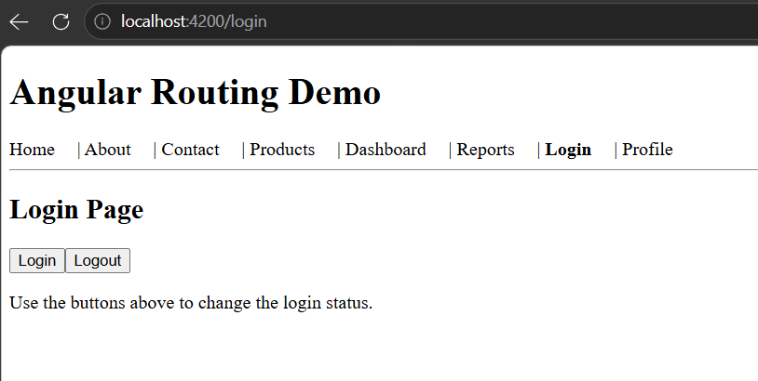

Test 2 (Logged In)
Visit:
http://localhost:4200/login
Click:
Login

This sets:
loggedIn = true;
Now visit:
http://localhost:4200/profile
Output:
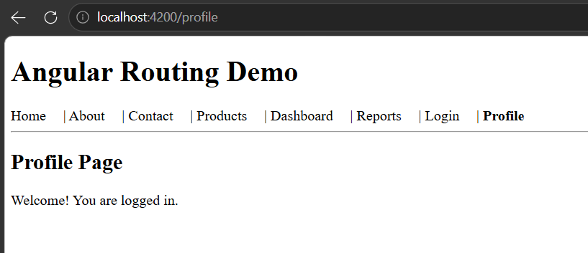

Test 3
Go back to: Login
Click
Logout
Now try /profile
Again you are redirected to

/login

